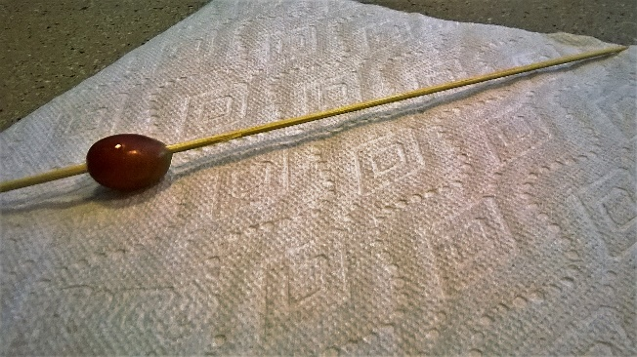
- Slide the grape onto the kabob stick.

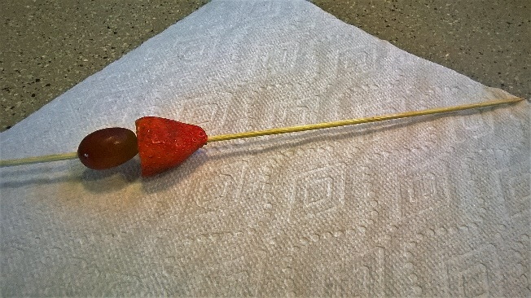
2. Slide the strawberry onto the kabob stick.

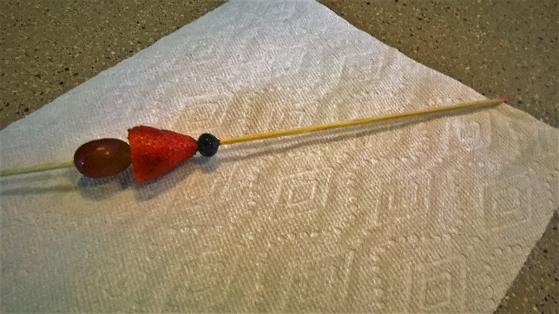
3. Slide the blueberry onto the kabob stick.

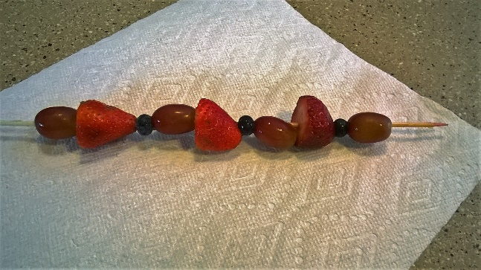
4. Repeat 1-3 until the kabob stick is full.

